Machine Learning and Demographic Contributors to Food Insecurity:

Random Forest Assessment of Census Data and Food Insecurity Rates in Suffolk County, Massachusetts

Margaret Clark[1]

Khoury College of Computer Sciences, Northeastern University

IA 2718 Research Methods in International Affairs

Dr. Nichola Minott

04/01/2024

## Abstract

This paper combines data science and social science methodologies to investigate food insecurity in Suffolk County, Massachusetts, focusing on urban American food systems and socio-economic factors. It utilizes Random Forest, a machine learning algorithm, to analyze demographic data from census tracts and determine their levels of correlation with food insecurity rates. The findings reveal significant relationships between Median Household Income, race demographics, unemployment, and food insecurity rates, highlighting the complex interplay of socio-economic factors in determining access to food. The paper also discusses the potential of machine learning in social science research and suggests avenues for future exploration to address food insecurity effectively.

**Introduction**

This paper seeks to combine the benefits of data science and social science to assess the food insecurity situation in Suffolk County, Massachusetts. It investigates urban American food systems, and how the association of various barriers to access can result in poor food access to varying degrees. Food insecurity is a prevalent issue in American cities and is influenced by many factors besides food access itself. Socio-economic factors, measured in census data as various demographics of a given tract, can also help explain why people struggle to afford their basic needs like food. The ways in which populations are underserved with insufficient aid or access to opportunities can be influenced by their employment, their race, and their income, which are explored in this work, as well as many other factors which could be explored in the future. The potential of machine learning to offer more information about how these factors interact cannot be overstated. A literature review of food access in the United States and the continued issue of food insecurity is presented first, followed by an introduction to machine learning for those who are familiar with the research field but may not have an understanding data science. This is followed by a study into the use of machine learning for the social sciences: how it has been used already and what it could be capable of doing. Finally, machine learning is utilized through the Random Forest algorithm to explore demographic data from Suffolk County census tracts and determine their relationships to food insecurity rates. Analysis of the most influential variables and their potential causes adds more to these findings. All pre-processing code and source information is provided for those who want to recreate the findings or mimic the steps for another similar social dataset.

**Literature Review**

**Urban American Food Insecurity**

This literature review covers works from the 20th and 21st century related to food access in the urban American environment, as well as a review on machine learning for the social sciences. This review was not done to the completion of all existing literature, but until I reached a point of sufficient knowledge on the research area. There is a good size of literature regarding food insecurity in the United States generally, but less in the specific area of machine learning research.

Food security as a term was developed in 1960 when the Declaration of Human Rights conditioned that every person deserves a livable supply of food to maintain productive well-being.[2] Similarly, the popular term “hunger” describes the lack of livable intake of calories.[3] Hunger, or food insecurity, remains a significant issue in the United States. In 2016, the USDA, or the United States Department of Agriculture, released a report which added food insecurity survey questions onto the United States Census Bureau’s Current Population Survey. This supplement was developed by the USDA Economic Research Service, and it inquired about varying levels of food insecurity: on general household food access, on adult food access, and on food access for children. 41,186 households completed the survey, and the statistics pulled from this work revealed that almost 13% of United States households were food insecure in the past year.[4] The health and wellbeing effects of food insecurity are significant. Poor nutrition can prevent people from taking necessary medications, and has been associated with type 2 diabetes, obesity, and chronic disease. In children, malnutrition leads to more hospitalizations as they become less protected against contracting illness and can experience stunted mental and physical development. [5] Data suggests that food aid programs are not sufficiently meeting the needs of hungry Americans, and what could be influential is small, consistent income boosts for households in need. [6] Food insecurity becomes especially risky as households struggle with income; in Boston specifically, almost 40% of public housing residents were believed to be food insecure as of 2012. Other stresses, including housing stress, can complicate one’s food access situation as individuals or household may relinquish their food needs in the face of economic hardship to serve other needs, such as feeding other members of the household, finding work, or affording housing. [7] Societal pressures like racism and discrimination have also been studied and correlated with food insecurity. Literature based in USDA data between 2001 and 2016 shows that black non-Hispanic households and Hispanic households consistently report food insecurity at rates twice that of households which are white and non-Hispanic.[8] Further research regarding demographic variables, food insecurity, and its adverse effects is an expressed need in the research community as of 2021. [9]

**Machine Learning: A Brief Introduction**

To discuss the topic of machine learning, one must first understand data science, because machine learning is a subset of the field of data science. Data science is the field of the exploration of data, including the processing of it, the handling of it, its analysis, and how it can be used. Hal Varian, chief economist of Google and a University of California at Berkeley information sciences, business, and economics professor said it best when he remarked, “The ability to take data — to be able to understand it, to process it, to extract value from it, to visualize it, to communicate it — that’s going to be a hugely important skill in the next decades.”[10] Data scientists are trained to hold large amounts of data and determine how best to apply it. This is especially useful in a time in the world where so much information is available; the ability to manipulate and understand it is incredibly important. Data science gives people the power to do more with what they already have: information. [11]

Machine learning is a fast-growing subfield within data science, with great promise to supplement work in almost every other field. Machine learning is the process of training a computer to learn from data without programming it to learn a certain way. [12] This is a part of a larger subfield in data science called artificial intelligence, the process of teaching computers to learn the way that humans learn. This sort of data science mimics neurological pathways and the way that human brains make decisions to allow computers, through machine learning, to quickly learn from large datasets what a human might learn from intensive study.

The best way to think about machine learning is to imagine someone gives a computer a photo of a person and asks it to identify them. In a human brain, one observes all the different aspects of a person’s face, and if those aspects add up to someone, they are familiar with, they can take the confirmation that all those parts add up to the right “whole” and identify the person. Computers do the same task, except they represent all these different sections of the given photo or, for example, a sentence wherein one is predicting the next word, and apply different mathematical processes to each part, making decisions on each one.[13] They can apply “importance” to different parts to determine if one part of the input is more helpful to determining the output than another. For example, if one’s goal is to determine the subject of the previous sentence, the word “importance” is more helpful than the word “the.” Other amazing ways machine learning, or “deep learning” can mimic human decision-making include natural language processing, self-operating technology like cars and home appliances, significant healthcare breakthroughs, digital marketing, and more. [14]

**Machine Learning, the Social Sciences, and Food Insecurity**

Machine learning is an exceptionally powerful tool for traversing great amounts of data. It is particularly useful for the social sciences, which deal significantly with great amounts of data concerning people, seeking out relationships and patterns. Social science has entered a new age where there is a significant amount of data for researchers to utilize.[15] Machine learning can sequentially and iteratively learn new information from datasets of great size, showing promise to the inductive social sciences. We are more capable in the contemporary period of pulling vast amounts of data, and that data will have many different features, which relate to one another in a variety of ways.

Learning how these features interact manually can be incredibly slow and complex.[16] Machine learning models can tackle subsets of the data, learn about how the different features produce different results in the data, and predict results of the rest of the data, which was not included in the subset, then checking their accuracy against the unused portion of the data. Researchers can then interact with their model and adjust it or select a new type of model with a different mathematical approach. Through interaction, researchers can learn about all aspects of the data, and take a model which works well to make accurate predictions about future data. The ultimate analysis, about the ability of the model to make reasonable predictions about the data, is where the social sciences can in turn help machine learning improve.[17] Understanding the context of social science data is exceptionally important to being able to analyze it properly; identifying this context is not something identified as necessary in the process of machine learning, because the focus is on the technical process and context varies so greatly. SOURCE Social scientists can use their tools of knowledge about social structures, how they interact, and what kind of environment their interaction results in to make strong predictions, accurate identifications, and thorough understanding of data.

There are already some groups doing exciting work in big data analysis and food insecurity. A recent work published in Nature Food argues specifically for the power of machine learning in guiding food security efforts.[18] Machine learning modelling can depict a constantly changing food access environment in real time, reveal which variables are driving trends and changes, and ultimately serve decision-makers in how to better direct their efforts. Earlier this year, the World Bank developed a World Food Security Outlook (WFSO) database to support efforts in achieving Sustainable Development Goals, specifically zero world hunger by 2030.[19] The WFSO allows for the monitoring of global food access, forecasting outcomes using data from historical and current figures. It can be challenging to achieve goals when the food access situation changes so quickly, and to understand exactly what picture data is painting when it is on such a huge scale. Data science offers a powerful tool to focus efforts on gaps and make rapid adjustments. These possibilities and their value are what I hope is revealed in this work.

**Methodology**

**Data Source Selection and Pre-Processing**

My methodology includes my selection of machine learning algorithm, my data source selection, my implementation of the algorithm. For this work, I use data provided by Feeding America and the Greater Boston Food Bank which was collected by the Metropolitan Area Planning Council, or MAPC, within their DataCommon.[20] My initial exploration looked into census data provided by the United States Census Bureau, however I found the MAPC dataset useful as it includes food insecurity rates and demographic data by census tract in one place, as well as a tabular structure well suited for visualizations. Some downsides of this dataset include that is slightly dated coming from 2015 and is limited in the amount of demographics it provides as features. However, being the cleanest dataset and thus easiest to manipulate and analyze, as well as coming from a reputable source, this dataset serves my purposes well.

There is data within this set for the entirety of Eastern Massachusetts, however I was especially interested in Suffolk County and the Boston area, so I limited the scope to Suffolk County. Each row within the dataset provides the Census 2010 Tract ID, the Municipality, the Neighborhood, the County Name, the Report Year, the Population size, the Food Insecurity Rate as a percentage of the population, the Unemployment Rate, the Poverty Rate, the Median Household Income, the percentage of the population which is Black, the percentage of the population which is Hispanic or Latino, the home ownership rate, the number of food insecure individuals, the percent of people below the SNAP threshold of 200% poverty, the percent of people above the SNAP threshold of 200% poverty, the cost of food index (which identifies the average cost of a given basket of food), the weekly food-budget shortfall per Food Insecure Individual, the total food-budget shortfall reported by the Food Insecure Individual, the weighted cost of an average meal, and finally, the meal gap. This data was used by the *Map the Meal Gap* study of Feeding America to determine where in America individuals eligible for SNAP were not receiving aid[21].

For pre-processing, or data preparation, I loaded the dataset into Jupyter Notebooks, a Python IDE (integrated development environment) a platform which provides for ease of coding and graph production. I used the Pandas library, an open-source data analysis and manipulation tool, to create a “Dataframe” or table[22]. I also used Matplotlib, which is a library that aids in graph and table representation of data and Scikit-learn, which is a Python tool for predictive data analysis. The importation of these libraries is shown in Figure 1, and in Figure 2 is shown the importing of the MAPC dataset. In Figure 3, I perform some preparation steps. I renamed the columns from their coding names to user-friendly names; for example, the “ct10_id” column became simply “Census Tract.” I limited the dataset to only Suffolk County. I dropped columns which were not applicable, and kept only the 'Census Tract', 'Neighborhood', 'County', 'Population Size', 'Food Insecurity Rate', 'Unemployment Rate', 'Poverty Rate', 'Median Household Income', 'Percent Black Individuals', 'Percent Latinx Individuals'', 'Percent Homeowning Individuals', 'Number Food Insecure Individuals', 'Percent Below SNAP Threshold', 'Percent Above SNAP Threshold' and 'Cost of Food Index'. I dropped entries which had missing data, leaving me with 169 census tracts to study. Below is provided my code in performing the pre-processing steps.

Figure 1



**Figure 2**

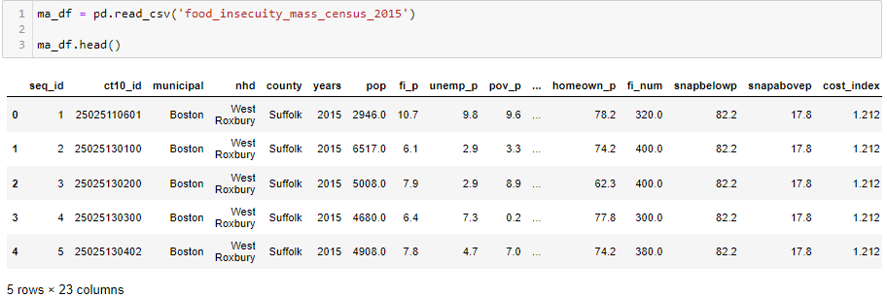

Figure 3

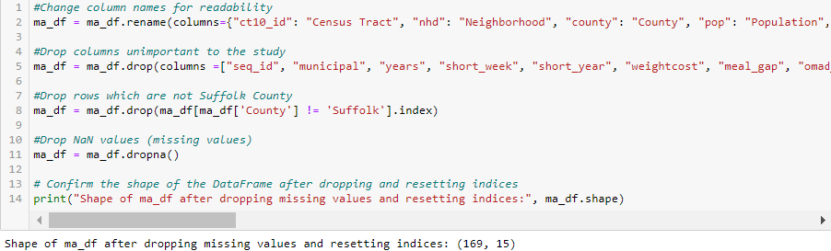

**Algorithm Selection**

For this work, I selected the Random Forest algorithm, which is subset of decision tree style learning in machine learning. Decision trees are the production of a tree-like structure representation of a dataset that represents a series of decisions made to learn about features of the data. It can perform both classification and regression tasks, meaning it is capable of making predictions regarding data which is categorical (classification) or data which is continuous (regression). This makes decision trees incredibly versatile and well-fitting for exploration of datasets of which there is little already known by the researcher. Random Forest is a special subset of decision trees as it merges the results of many decision trees into a “forest” to improve the prediction quality. This practice is referred to as bagging ensemble learning, regarding the combination of multiple models. This strategy results in a model that can account for more variance in the data and produce more accuracy. It is especially useful in research when wanting to avoid “overfitting,” when a machine learning model fits too closely to the data it is given to train with and produces results which only work well for the given dataset. This works well for datasets in which the consistency of its state and the relationships between its variables in the future is not guaranteed. It also works well for data with high dimensionality, where the number of considered features compared to the number of data entries is high SOURCE.

There are several “hyperparameters” which must be considered and tuned when using the Random Forest model. Hyperparameters are mathematical determinants which contribute to the results of the model; these can improve the accuracy and predictive power of the model or improve the speed of the model. One of the downsides of Random Forest modelling is that it can be comparatively slow, especially for very large datasets. In this case, I employ max-features, which is the maximum amount of features considered by the model before “splitting a node” (making a decision), mini_sample_leaf, which selects the minimum amount of leaves needed to split an internal node (decisions within decision), max_leaf_nodes, which allows the maximum leaf nodes in each tree (leaf nodes being points in which further decision splitting cannot be done thus resulting in a final outcome), and n_estimators, which is the amount of trees built by the model before finding the average of all the predictions. These can be tuned to adjust the accuracy of the model. I employ specifically “feature importance” in Random Forests, which calculates the importance of different features in determining the target variable. Below is provided the code in which I utilize the Random Forest Classifier and determine the best hyperparameters. The output below the code block provides the accuracy of the model and the determined best parameters. My code for programming the model is shown in Figure 4.

Figure 4

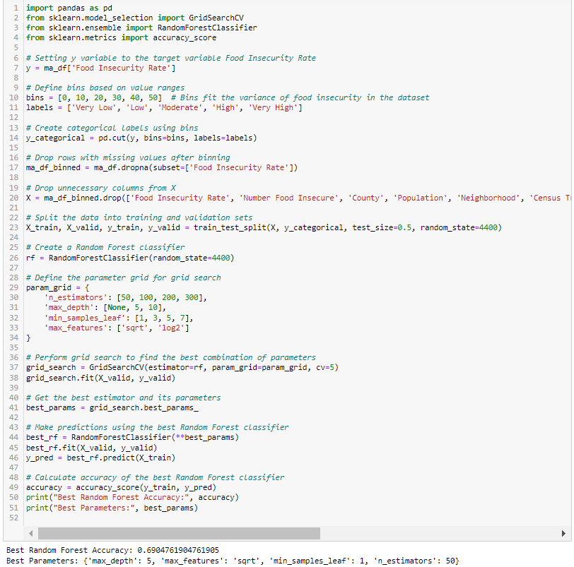

**Findings and Analysis**

The findings of this paper show relationships between social demographic factors and economic demographic factors in determining food insecurity rates. In this work, the target variable is food insecurity rates in different census tracts in Suffolk County. Demographic data about those same census tracts is provided as the determining features, and with Random Forests, I can find which demographic features have the biggest influence on determining the food insecurity rate of a given census tract. This informs on what demographics have the strongest associations with food insecurity, and thus where food access may be failing the population of Suffolk County. Below is provided the Python code in Jupyter Notebook. In Figure 5 is the code to produce the variable importance chart, and finally, in Figure 6, the chart itself, displaying which factors were the biggest contributors to the food insecurity rates.

Figure 5

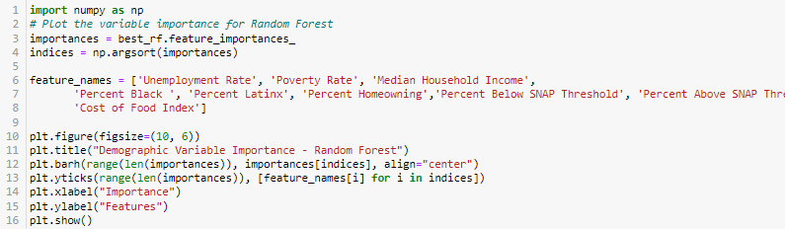

Figure 6

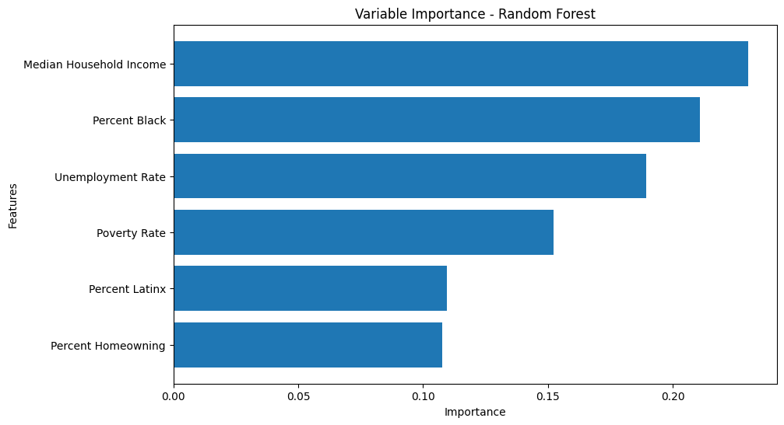

**Analysis**

The Random Forest Variable Importance chart reveals potential patterns between demographic variables and food insecurity in Suffolk County households. Model accuracy was achieved to a rounded 70%, as shown in the bottom output of Figure 4. This level ensures that the given features can exactly predict the outcome of the percentage of food insecurity in each census tract for 70% of the given 169 examples, proving that these factors can be predicted to correlate with food insecurity with reliable accuracy. The success of the tuning of this algorithm suggests that relationships likely exist between household socio-economic indicators and their food access situation.

The most prominent pattern was revealed to be between Median Household Income. At about 25% on the Variable Importance- Random Forest plot shown in Figure 6, Median Household Income was the determining factor at node separations 25% of the time, making out that a quarter of the data was pulled by the influence of this metric. This suggests that for this dataset, income is the most important determining factor in a household’s food insecurity situation. This could be attributed to high food prices in the given county; however, it could also be associated with other costs of living such as housing, transportation, healthcare, education, and more. Income being a more important factor than unemployment might suggest insufficient wage trends in the area; despite being employed, households still struggle to afford necessities. More research into household expenditures in Suffolk County could inform better on household expenditures. This might inform also on how accurate food insecurity statistics are; in the case of a house where individuals are giving up regular meals to afford another cost of living, or vice versa, they are relinquishing another need to afford food, which they cannot go without. That house might be falsely identified as food secure when their real situation is much more complicated.

While Median Household Income was the most dominant deciding factor, Percent Black Households in a census tract was a close second in importance. More than Unemployment Rate or even Poverty Rate, despite Median Household Income being the most prevalent. Race being so closely tied to food insecurity is extremely telling about the influence of social barriers on Americans’ experiences. The close correlation between food insecurity and race percentage of a census tract suggests race acts as a systemic factor inhibiting peoples’ agency. This could involve a variety of different sources, including stigma, discrimination, and historically prevented access to fair wages, employment, education, housing, and healthcare. Its continued dominance to this day is evidence that sufficient efforts have not been made to rectify race prejudice. The relationship between food insecurity rates and percent black populations could mean race continues to be weaponized against Suffolk County residents, and more research needs to be done as to exactly how race influences food access.

At almost 20% as a determining factor and third of the demographics, the Unemployment Rate remains a significant barrier to food security. Unreliable income can dramatically exacerbate food insecurity. SNAP (Supplemental Nutrition Assistance Program) is an important United States food aid program serving citizens, and one of the most important barriers to food insecurity, but it may not be sufficiently meeting the amount of people who need help or sufficiently meeting the needs of those who participate in it. In the case of employment, SNAP also has conditional benefits based on work requirements. Though it does provide aid to food insecure people between employment, if an individual is considered eligible for work based on SNAP regulations, they can lose access to benefits.[23] If individuals find issues establishing their right as ineligible to work or struggle to find work, the loss of SNAP benefits could push them further into food insecurity. After Unemployment Rate, Poverty Rate, Percent Latinx, and percent Homeowning all showed a non-negligible relationship to food insecurity. With Percent Latinx and Percent Homeowning having a near equivalent relationship, while there is no guarantee of a relationship between these two factors, they may influence food access is aligning ways.

Future research into this topic would benefit from exploring further demographic variables such as access to education and healthcare and gender. Identifying the ties that lead these variables to correlate with food insecurity and working with a larger variety of data sources and more recent data sources would also be beneficial. The COVID-19 pandemic could have influenced food access in Suffolk County significantly and occurred after this data was collected. Different demographic groups in Suffolk County may also experience food insecurity in different ways. Asking more survey questions to get more in depth detailing people’s food access situations in Suffolk County would help paint a clearer picture of where negative patterns in access are formed. Similar assessments of other large cities in different regions of the U.S., and their food access environments, would add useful perspectives.

**Conclusion**

In sum, machine learning offers an effective strategy for exploring social science studies further, in this case, food insecurity in United States cities. Food insecurity can be a deceivingly complex situation which deserves further study to fully understand its causes and effects. Studying the influence of various demographic variables on food insecurity rates allows us a new perspective on how food access plays out in Suffolk County. Identifying which groups of people are underserved and why informs on how aid distributed to citizens fails and succeeds. In a modern age with a plethora of social information on aid recipients, machine learning can help navigate large datasets. It offers many different tools that can pull previously unseen trends and connections. Random Forest is a multi-purpose algorithm with significant benefits for social science research, and in this work, revealed that socio-economic characteristics of Suffolk County census tracts likely contribute to rates of food insecurity. Median Household Income was the most influential factor at 25% importance, but it is closely followed by Percent Black residents and Unemployment Rate. Suffolk County households may struggle with rising costs, minimal employment access, and racial prejudice. Economic barriers will evidently prevent quality food access, and their strong influence means aid programs may benefit from more government support, reorganization, or ensuring regulations are not preventing those in need from accessing aid. Social barriers complicate food access at every level, and these findings are proof that despite progress they still rival other barriers in interrupting food access. More research into how these barriers play out would add beneficial context to this work, as well as repeating this process with a more recent data set to explore if there have been any changes in recent years. Machine learning can support social science exploration and allow it to accomplish more analysis on a larger scale. Identifying the biggest influences on food security helps direct efforts where they are most needed, and create a more equitable, just society where all peoples’ needs are met.

1. Margaret Clark, Bachelor’s Candidate, Data Science and International Affairs, Northeastern University, 360 Huntington Ave, Boston, MA, U.S.A., +1-423-208-4771; clark.marg@northeastern.edu
2. Norhasmah, S. Jr., Zalilah, M.S., Mohd Nasir, M.T., Kandiah, M., & Asnarulkhadi, A.S. "A Qualitative Study on Coping Strategies among Women from Food Insecurity Households in Selangor and Negeri Sembilan." Malaysian Journal of Nutrition 16, no. 1 (2010): 39–54. PubMed database.
3. “Hunger and Food Insecurity.” Food and Agriculture Organization of the United Nations, 2024. https://www.fao.org/hunger/en/#:~:text=People%20experiencing%20severe%20food%20insecurity,determined%20based%20on%20the%20POU.
4. Coleman-Jensen, Alisha et al. “Household Food Security in the United States in 2016.” U.S. Department of Agriculture, Economic Research Service, 2017.
5. Hampton, T. "Food Insecurity Harms Health, Well-being of Millions in the United States." JAMA 298, no. 16 (2007): 1851–1853. DOI: 10.1001/jama.298.16.1851.
6. Nelson, K., Brown, M.E., Lurie, N. "Hunger in an Adult Patient Population." JAMA 279, no. 15 (1998): 1211–1214. DOI: 10.1001/jama.279.15.1211.
7. Nebbitt, V.E., Lombe, M., Chu, Y., Sinha, A., Tirmazi, T. "Correlates of Food Security among Low-Resource Young People: An Assessment of Community Protective Factors within Public Housing Neighborhoods." J Health Care Poor Underserved 27, no. 3 (2016): 1126-1142. DOI: 10.1353/hpu.2016.0119. PMID: 27524756.
8. Odoms-Young, A., & Bruce, M.A. "Examining the Impact of Structural Racism on Food Insecurity: Implications for Addressing Racial/Ethnic Disparities." Family & Community Health 41 Suppl 2 (2018): S3–S6. DOI: 10.1097/FCH.0000000000000183.
9. Quintiliani, L.M., Whiteley, J.A., Zhu, J., Quinn, E.K., Murillo, J., Lara, R., & Kane, J. "Examination of Food Insecurity, Socio-Demographic, Psychosocial, and Physical Factors among Residents in Public Housing." Ethnicity & Disease 31, no. 1 (2021): 159–164. DOI: 10.18865/ed.31.1.159.
10. Harrington, Peter. Machine Learning in Action. Manning Publications Co., USA, 2012.
11. Power, Daniel J. "Using 'Big Data' for Analytics and Decision Support." Journal of Decision Systems 23, no. 2 (2014): 222-228. DOI: 10.1080/12460125.2014.888848.
12. Baştanlar, Y., and M. Özuysal. "Introduction to Machine Learning." In miRNomics: MicroRNA Biology and Computational Analysis, edited by M. Yousef and J. Allmer, 171-189. Methods in Molecular Biology, vol 1107. Totowa, NJ: Humana Press, 2014. DOI: 10.1007/978-1-62703-748-8_7.
13. Cross, Simon S., Robert F. Harrison, and R. L. Kennedy. 1995. "Introduction to Neural Networks." The Lancet 346 (8982) (Oct 21): 1075-9. https://link.ezproxy.neu.edu/login?url=https://www.proquest.com/scholarly-journals/introduction-neural-networks/docview/199029017/se-2.
14. Shuaib, Muhammad, Juliana Jaafar, Mohammad Faizuddin, and Shahrulniza Musa. “Review on Recent Trends and Challenges in Deep Learning and Artificial Intelligence.” In AIP Conference Proceedings, Vol. 2617. Melville: American Institute of Physics, 2022. https://doi.org/10.1063/5.0119678.
15. Halford, Susan, and Mike Savage. “Speaking Sociologically with Big Data: Symphonic Social Science and the Future for Big Data Research.” Sociology (Oxford) 51, no. 6 (2017): 1132–48. https://doi.org/10.1177/0038038517698639.
16. González-Bailón, Sandra. “Social Science in the Era of Big Data.” Policy and Internet 5, no. 2 (2013): 147–60. https://doi.org/10.1002/1944-2866.POI328.
17. Grimmer, Justin, Margaret E. Roberts, and Brandon M. Stewart. “Machine Learning for Social Science: An Agnostic Approach.” Annual Review of Political Science 24, no. 1 (May 11, 2021): 395–419. https://doi.org/10.1146/annurev-polisci-053119-015921..
18. Martini, G., Bracci, A., Riches, L. et al. Machine learning can guide food security efforts when primary data are not available. Nat Food 3, 716–728 (2022). https://doi.org/10.1038/s43016-022-00587-8
19. World Bank. "Navigating the Future of Food Security with Machine Learning." World Bank Blogs. Accessed March, 2024, https://blogs.worldbank.org/en/opendata/navigating-future-food-security-machine-learning.
20. Greater Boston Food Bank, Feeding America. Food Insecurity rates and Meal Gap (Census Tracts - Eastern MA), 2015. Distributed by Metropolitan Area Planning Council (MAPC). https://datacommon.mapc.org/browser/datasets/322.
21. “Map the Meal Gap.” Hunger & Poverty in the United States, 2021. https://map.feedingamerica.org/.
22. “Pandas.” pandas, 2024. https://pandas.pydata.org/.
23. “Work Rules for SNAP Clients.” Mass.gov, 2024. https://www.mass.gov/info-details/work-rules-for-snap-clients.